**Cryptography And Network Security Lab**

**Assignment submission**

**PRN No: 2019BTECS00017**

**Full name: Muskan Raju Attar**

**Batch: B5**

**Assignment: 13**

**Title of assignment: Implementation of SHA – 512 (Secured Hash Algorithm)**

**Title:**

Implementation of SHA – 512 (Secured Hash Algorithm)

**Aim:**

To develop and implement the SHA – 512 (Secured Hash Algorithm)

**Theory:**

* SHA-2 (Secure Hash Algorithm 2) is a set of cryptographic hash functions designed by the United States National Security Agency (NSA) and first published in 2001.
* They are built using the Merkle–Damgård construction, from a one-way compression function itself built using the Davies–Meyer structure from a specialized block cipher.
* SHA-2 includes significant changes from its predecessor, SHA-1. The SHA-2 family consists of six hash functions with digests (hash values) that are 224, 256, 384 or 512 bits.
* SHA-512, or Secure Hash Algorithm 512, is a hashing algorithm used to convert text of any length into a fixed-size string. Each output produces a SHA-512 length of 512 bits (64 bytes). This algorithm is commonly used for email addresses hashing, password hashing, and digital record verification.

**Implementation of SHA 512 (Secured Hash Algorithm)**

**Code:**

#include<bits/stdc++.h>

#define ull unsigned long long

#define SHA_512_INPUT_REPRESENTATION_LENGTH 128

#define BLOCK_SIZE 1024

#define BUFFER_COUNT 8

#define WORD_LENGTH 64

#define ROUND_COUNT 80

using namespace std;

void initialiseBuffersAndConstants(vector<ull>& buffers, vector<ull>& constants)

{

buffers = {

0x6a09e667f3bcc908, 0xbb67ae8584caa73b, 0x3c6ef372fe94f82b, 0xa54ff53a5f1d36f1,

0x510e527fade682d1, 0x9b05688c2b3e6c1f, 0x1f83d9abfb41bd6b, 0x5be0cd19137e2179

};

constants = {

0x428a2f98d728ae22, 0x7137449123ef65cd, 0xb5c0fbcfec4d3b2f, 0xe9b5dba58189dbbc, 0x3956c25bf348b538,

0x59f111f1b605d019, 0x923f82a4af194f9b, 0xab1c5ed5da6d8118, 0xd807aa98a3030242, 0x12835b0145706fbe,

0x243185be4ee4b28c, 0x550c7dc3d5ffb4e2, 0x72be5d74f27b896f, 0x80deb1fe3b1696b1, 0x9bdc06a725c71235,

0xc19bf174cf692694, 0xe49b69c19ef14ad2, 0xefbe4786384f25e3, 0x0fc19dc68b8cd5b5, 0x240ca1cc77ac9c65,

0x2de92c6f592b0275, 0x4a7484aa6ea6e483, 0x5cb0a9dcbd41fbd4, 0x76f988da831153b5, 0x983e5152ee66dfab,

0xa831c66d2db43210, 0xb00327c898fb213f, 0xbf597fc7beef0ee4, 0xc6e00bf33da88fc2, 0xd5a79147930aa725,

0x06ca6351e003826f, 0x142929670a0e6e70, 0x27b70a8546d22ffc, 0x2e1b21385c26c926, 0x4d2c6dfc5ac42aed,

0x53380d139d95b3df, 0x650a73548baf63de, 0x766a0abb3c77b2a8, 0x81c2c92e47edaee6, 0x92722c851482353b,

0xa2bfe8a14cf10364, 0xa81a664bbc423001, 0xc24b8b70d0f89791, 0xc76c51a30654be30, 0xd192e819d6ef5218,

0xd69906245565a910, 0xf40e35855771202a, 0x106aa07032bbd1b8, 0x19a4c116b8d2d0c8, 0x1e376c085141ab53,

0x2748774cdf8eeb99, 0x34b0bcb5e19b48a8, 0x391c0cb3c5c95a63, 0x4ed8aa4ae3418acb, 0x5b9cca4f7763e373,

0x682e6ff3d6b2b8a3, 0x748f82ee5defb2fc, 0x78a5636f43172f60, 0x84c87814a1f0ab72, 0x8cc702081a6439ec,

0x90befffa23631e28, 0xa4506cebde82bde9, 0xbef9a3f7b2c67915, 0xc67178f2e372532b, 0xca273eceea26619c,

0xd186b8c721c0c207, 0xeada7dd6cde0eb1e, 0xf57d4f7fee6ed178, 0x06f067aa72176fba, 0x0a637dc5a2c898a6,

0x113f9804bef90dae, 0x1b710b35131c471b, 0x28db77f523047d84, 0x32caab7b40c72493, 0x3c9ebe0a15c9bebc,

0x431d67c49c100d4c, 0x4cc5d4becb3e42b6, 0x597f299cfc657e2a, 0x5fcb6fab3ad6faec, 0x6c44198c4a475817

};

}

string sha512Padding(string input)

{

string finalPlainText = "";

for(int i=0 ; i<input.size() ; ++i)

{

finalPlainText += bitset<8>((int)input[i]).to_string();

}

finalPlainText += '1';

int plainTextSize = input.size() * 8;

int numberOfZeros = BLOCK_SIZE - ((plainTextSize + SHA_512_INPUT_REPRESENTATION_LENGTH + 1) % BLOCK_SIZE);

while(numberOfZeros--)

{

finalPlainText += '0';

}

finalPlainText += bitset<SHA_512_INPUT_REPRESENTATION_LENGTH>(plainTextSize).to_string();

cout<<"Plain text length = "<<plainTextSize<<endl;

cout<<"Plain text length after padding = "<<finalPlainText.length()<<endl<<endl;

return finalPlainText;

}

ull getUllFromString(string str)

{

bitset<WORD_LENGTH> word(str);

return word.to_ullong();

}

static inline ull rotr64(ull n, ull c)

{

const unsigned int mask = (CHAR_BIT * sizeof(n) - 1);

c &= mask;

return (n>>c) | (n<<((-c)&mask ));

}

int main()

{

vector<ull> buffers(BUFFER_COUNT);

vector<ull> constants(ROUND_COUNT);

initialiseBuffersAndConstants(buffers, constants);

cout<<"Enter Text: ";

string input;

getline(cin, input);

cout<<"Input: "<<input<<endl;

string paddedInput = sha512Padding(input);

cout<<"Padded Input:"<<" "<<paddedInput<<endl<<endl;

for(int i=0 ; i<paddedInput.size() ; i+=BLOCK_SIZE)

{

string currentBlock = paddedInput.substr(i, BLOCK_SIZE);

vector<ull> w(ROUND_COUNT);

for(int j=0 ; j<16 ; ++j)

{

w[j] = getUllFromString(currentBlock.substr(j, WORD_LENGTH));

}

for(int j=16 ; j<80 ; ++j)

{

ull sigma1 = (rotr64(w[j-15], 1)) ^ (rotr64(w[j-15], 8)) ^ (w[j-15] >> 7);

ull sigma2 = (rotr64(w[j-2], 19)) ^ (rotr64(w[j-2], 61)) ^ (w[j-2] >> 6);

w[j] = w[j-16] + sigma1 + w[j-7] + sigma2;

}

ull a = buffers[0], b = buffers[1], c = buffers[2], d = buffers[3];

ull e = buffers[4], f = buffers[5], g = buffers[6], h = buffers[7];

for(int j=0 ; j<ROUND_COUNT ; ++j)

{

ull sum0 = (rotr64(a, 28)) ^ (rotr64(a, 34)) ^ (rotr64(a, 39));

ull sum1 = (rotr64(e, 14)) ^ (rotr64(e, 18)) ^ (rotr64(e, 41));

ull ch = (e && f) ^ ((!e) && g);

ull temp1 = h + sum1 + ch + constants[i] + w[i];

ull majorityFunction = (a && b) ^ (a && c) ^ (b && c);

ull temp2 = sum0 + majorityFunction;

h = g;

g = f;

f = e;

e = d + temp1;

d = c;

c = b;

b = a;

a = temp1 + temp2;

}

buffers[0] += a;

buffers[1] += b;

buffers[2] += c;

buffers[3] += d;

buffers[4] += e;

buffers[5] += f;

buffers[6] += g;

buffers[7] += h;

}

cout<<"Output of SHA-512 Algorithm: "<<endl;

for(int i=0 ; i<BUFFER_COUNT ; ++i)

{

cout << setfill('0') << setw(16) << right << hex << buffers[i];

}

return 0;

}

**Output:**

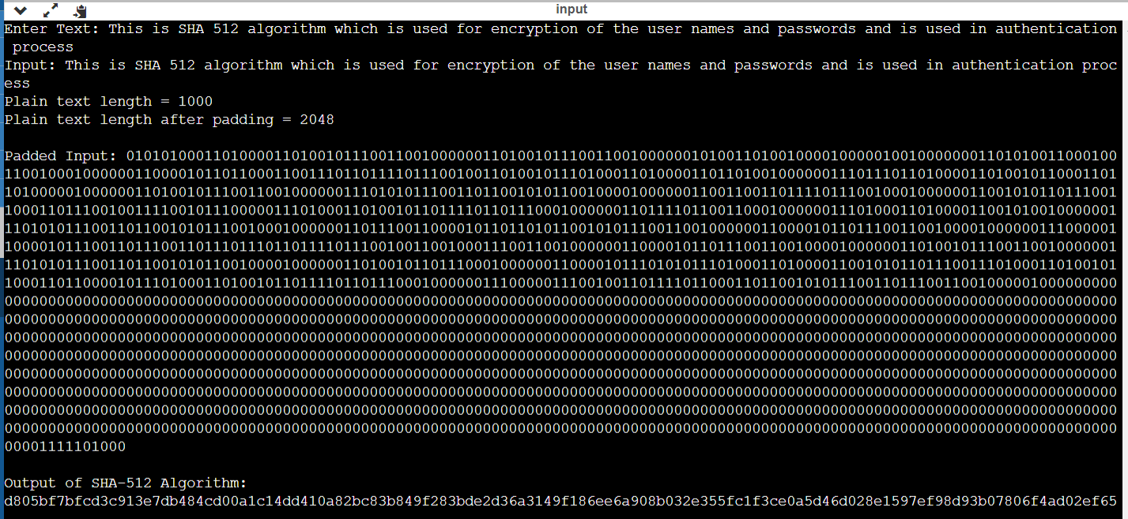

**Conclusion:**

The SHA 512 can be used for authentication process.